1. mysql -h 127.0.0.1 -u root -p password

2. CREATE USER 'userone' IDENTIFIED BY 'passwordone'

GRANT SELECT,UPDATE, DELETE ON . to 'userone'

3.select TrxID, count(TrxID) as total from transactions

group by TrxID

having total > 1

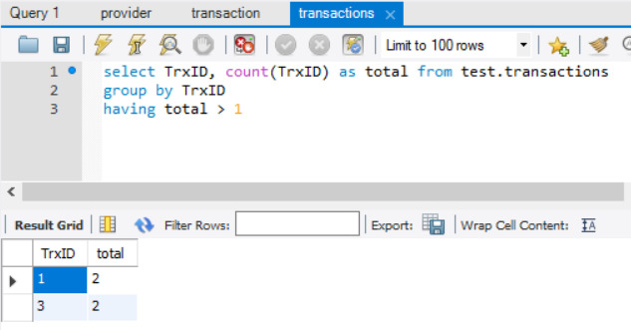

4. SELECT TrxId, MSISDN, ProviderName FROM transaction

left join provider on transaction.ProviderID = provider.ProviderID